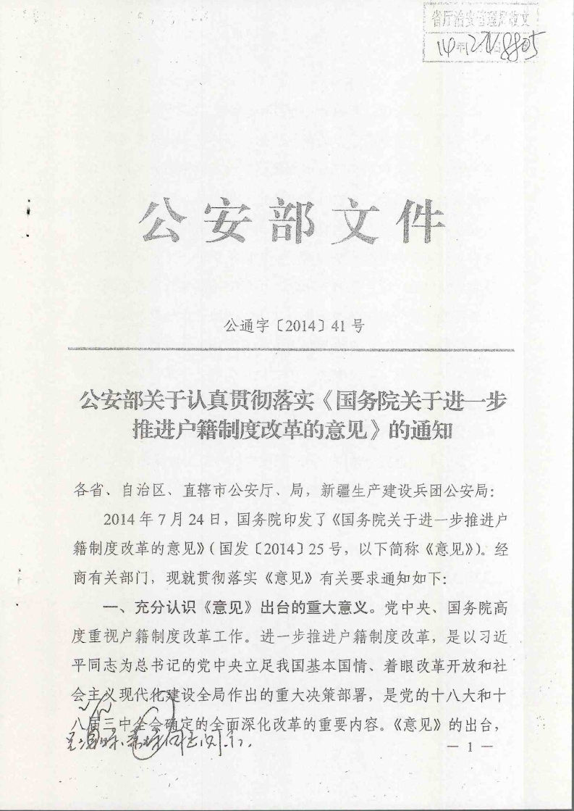

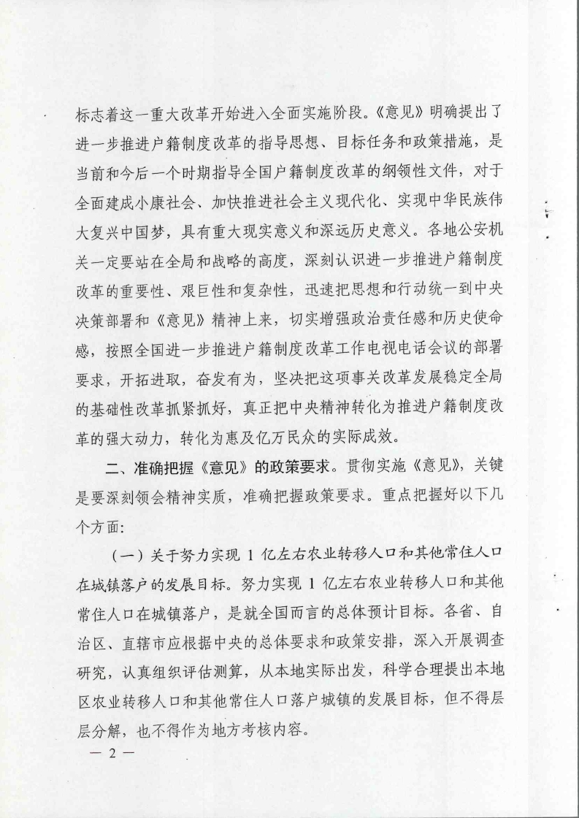
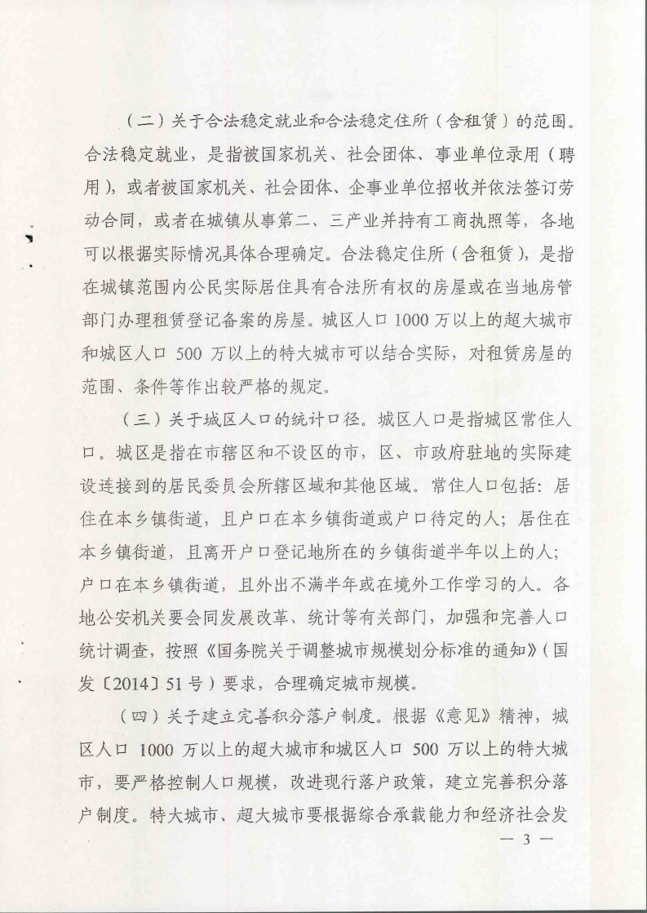
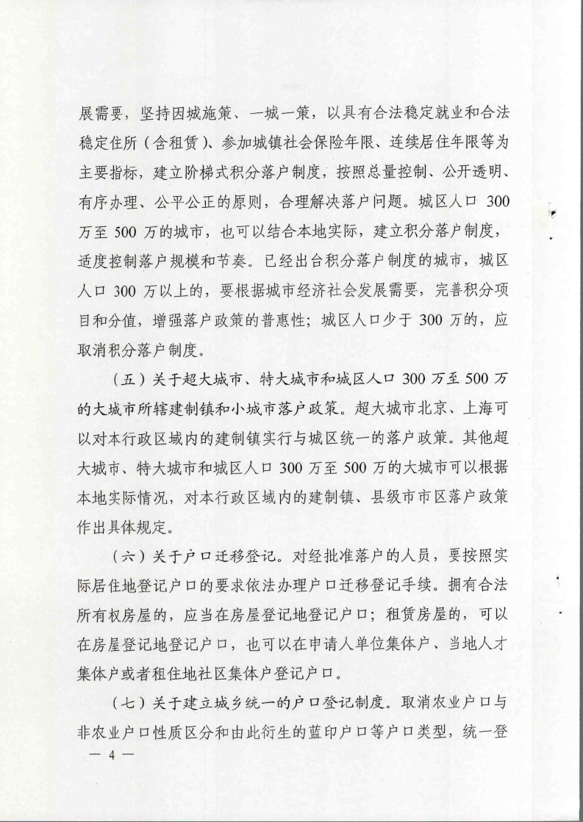
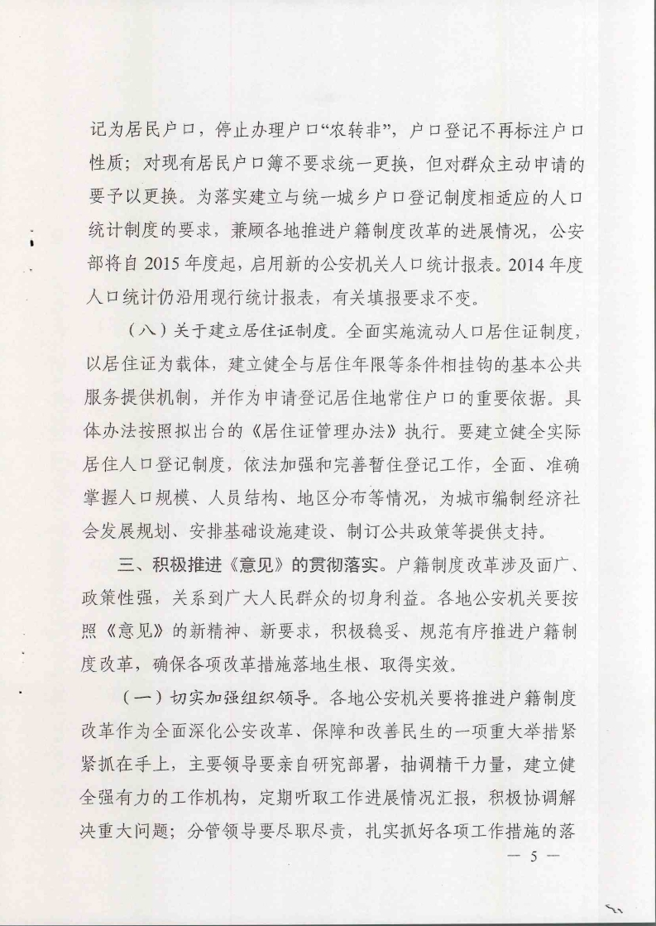
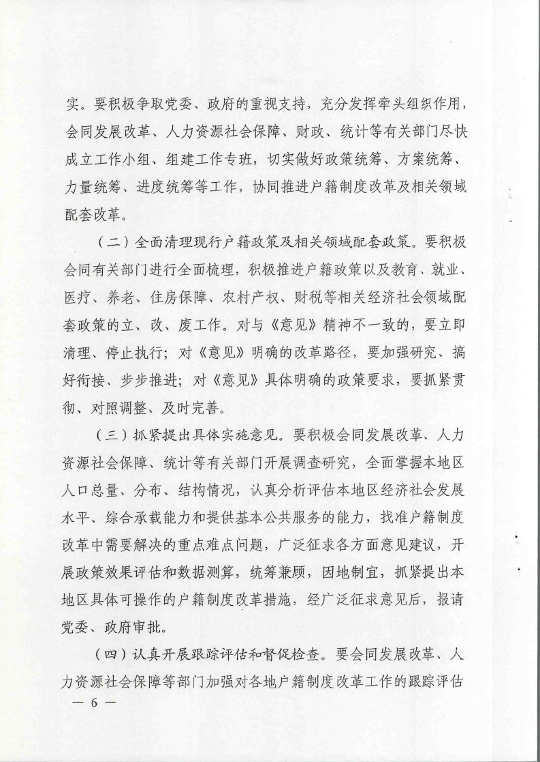
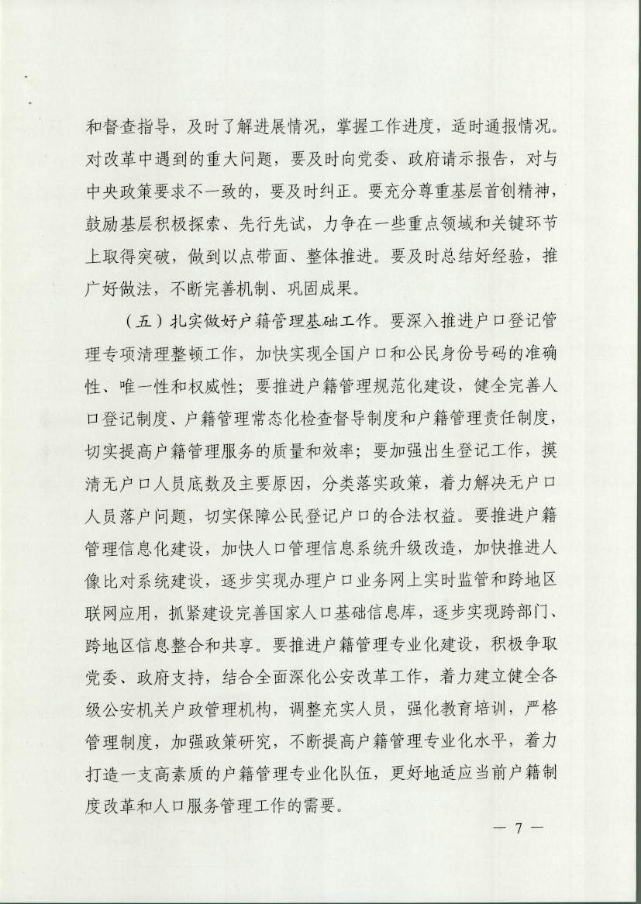
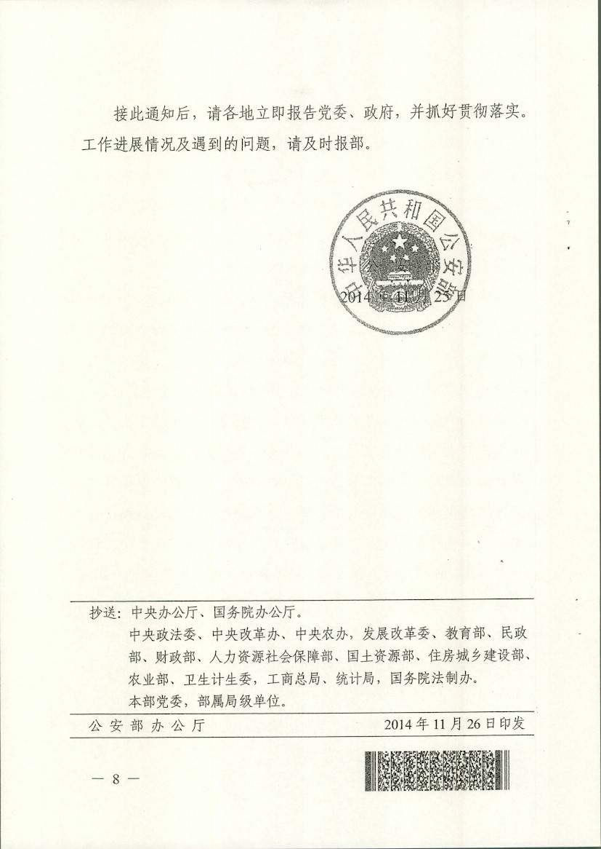

------------------------------------------------------------------------------------------------------------------------------------------------------------------------------------------------------------------------------------------------------------------------------------------------------------------------------------------------------------------------------------------------------------------------------------------------------------------------------------------------------------------------------------------------------------------------------------------------------------------ 广东省公安厅办公室翻印 2014年12月31日
-------------------------------------------------------------------------------------------------------------------------------------------------------------------------------------------------------------------------------------------------------------------------------------------------------------------------------------------------------------------------------------------------------------------------------------------------------------------------------------------------------------------------------------------------------------------------------------------------------------------

